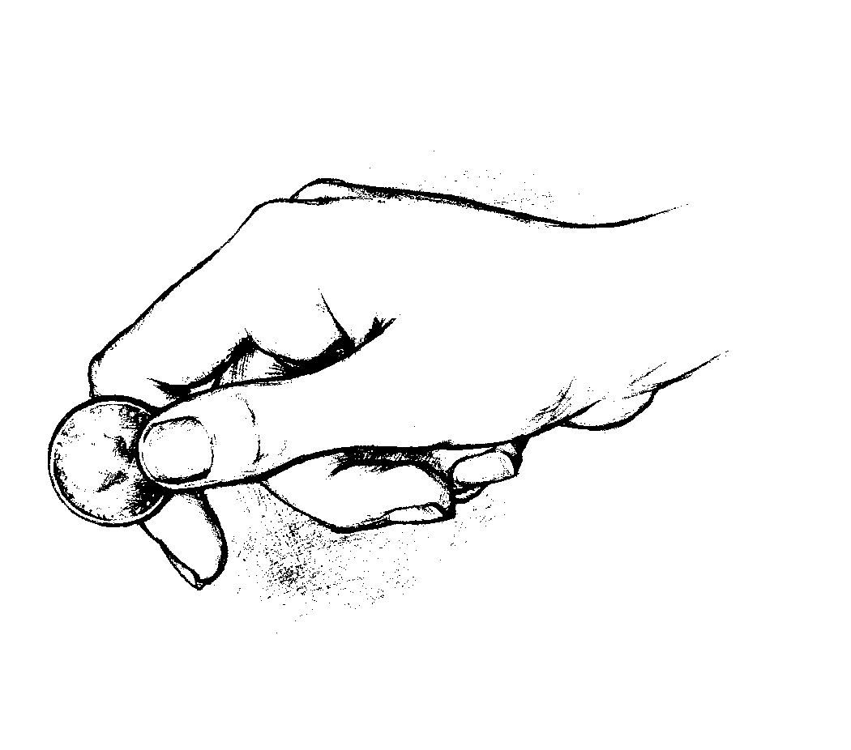
A tithe of everything… belongs to the Lord. Leviticus 27:30 _{NIV}

